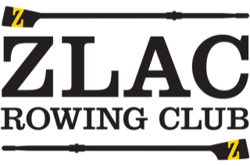

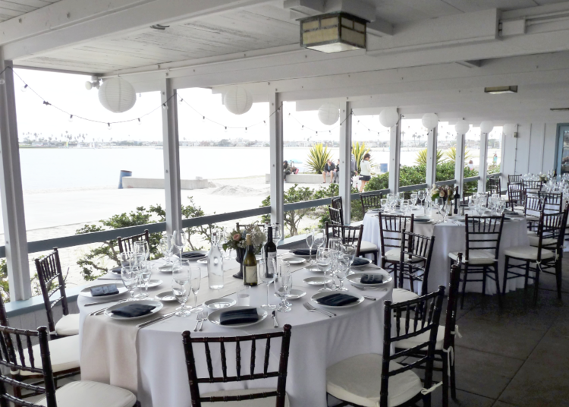

RENTAL INFORMATION
1111 Pacific Beach Drive ~ San Diego, CA 92109
858-274-0661
rentals@zlac.org

FOR THE RENTER
Event ___________________________
Date_________________
Welcome to ZLAC! We are pleased that you have selected our beautiful facility for your event. To make it a good experience for all please read over the following reminders.
- You have rented our facility for a certain number of hours. In order to avoid incurring overtime rates, you should encourage your guests to be out of the building by the end time designated in your contract. All property belonging to you, your guests, the caterer, or other services hired or rented must be removed from the premises and the parking lot cleared of cars within an hour of the end of the event.

- The rental fee, which is separate from the deposit, is due two months prior to your event.

- ZLAC has tables that can be set up by staff for your event to your specifications. Your floor plan should be returned to the resident manager at least two weeks in advance of your rental. NO ZLAC furniture may be moved out of the building.

- Decorations may not be fastened or tacked to the walls, draperied, floors or furniture, either indoors or outdoors.

- You are responsible for any damage to ZLAC property including damage caused by guests, music provider, caterer, or other services hired. Please provide a Certificate of Liability Insurance of not less than one million dollars per incident naming ZLAC Rowing Club, LTD as the additional insured including a host liquor liability provision. Our resident manager can provide some information for you.

- Caterers that have not worked at ZLAC during the past calendar year must schedule a walk-through with the resident manager two months prior to the event. Proof of current liability insurance including liquor liability is required.

- No ZLAC kitchen items are to be used. Your caterer must provide chairs and all tableware, including glasses, dishes, flatware, serving trays, and linens.

- The ZLAC kitchen may be used for warming, refrigerating or serving food. No food preparation is allowed. The kitchen is to be left clean and in good order. There is a list posted in the kitchen detailing the clean-up procedures.

- Hard liquor is prohibited. A hosted bar with wine, beer, champagne and non-alcoholic beverages must be staffed by your caterer or licensed bartender. No tip jars please. Beverage service is not to begin before the rental hour stated on the contract and must cease 30 minutes before the end of your event. No minors shall be served or allowed to consume alcoholic beverages on the premises. Alcohol may not be consumed on the beach.

- Due to residential nature of the area, noise volume may not exceed 55 decibels after 7pm. Low level music and microphones are allowed on the beach and outside the clubhouse for ceremonies and announcements. All dance music must be inside the clubhouse. No smoke machines, foggers or sparklers are allowed. Microphones and Music must cease 30 minutes before the end of your event.

- All trash must be bagged and put in the dumpster. Caterer should provide their own clear trash bags for this purpose.

- There is no smoking in the Clubhouse or premises with the exception of a designated area near the garage outside in the parking lot.

- The ZLAC manager or designee will be onsite during your rental and is authorized to enforce all rental conditions.
ZLAC Rowing Club, Ltd.
1111 Pacific Beach Drive ~ San Diego, CA 92109 ~ 858-274-0661
IMMEDIATELY
CHECKLIST
Your signed Contract and a $500 deposit will confirm your date. Contact our Resident manager
to pay by credit card.

TWO MONTHS PRIOR TO EVENT
Pay rental fee and submit Proof of Liability Insurance Certificate
Provide list of venders with contact information to Resident manager
Caterer
Bartender
Music Provider
Rentals
Confirm decorating schedule and other logistics with Resident Manager
TWO WEEKS PRIOR TO EVENT
Submit facility map with preferred table set up
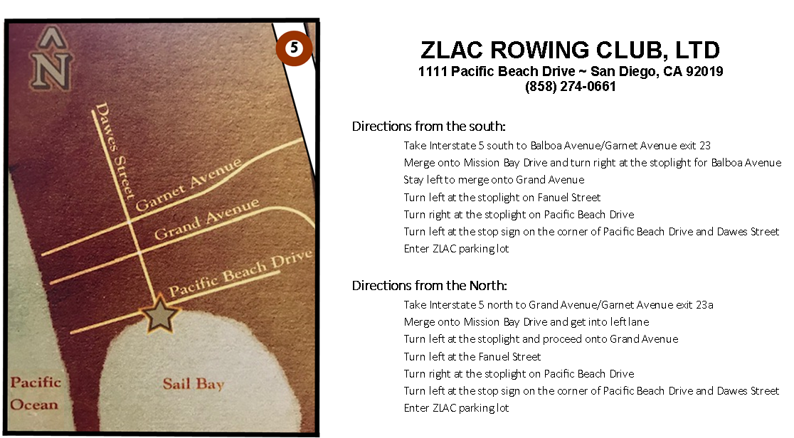
ZLAC ROWING CLUB, LTD
1111 Pacific Beach Drive ~ San Diego, CA 92109
(858) 274-0661

FOR THE CATERER
Event ___________________________
Date of Event_____________________
Start time _______ End Time _______
Date_________________

We are happy to welcome you back and ask that you read our updated reminders. Please contact our resident manager at 858-274-0661 to see if a site visit is required and to have any questions answered. Be sure to provide a current copy of your liquor license and liability insurance.
- Catering staff is allowed generally about 2 hours before indicated start time on the contract and should vacate the premises no later than 1 hour following the event.

- The renter has been provided with a list of table sizes and has been asked to submit a floor plan at least two weeks in advance. ZLAC staff will set up tables as indicated the day of the event.

- You or the renter must provide the chairs and all tableware including glasses, dishes, flatware, serving trays, and linens. No ZLAC kitchen items are to be used.

- Hard liquor is prohibited. A hosted bar with wine, beer, champagne and non-alcoholic beverages may be served by your staff or by a hired licensed bartender. No tip jars please. Beverage service is not to begin before the rental hour stated on the contract and must cease 30 minutes before the end of the event. No minors shall be served or allowed to consume alcoholic beverages on the premises. Alcohol may not be consumed on the beach.

- Please note that all events must end no later than 10 pm with the premises vacated by 11 pm.

- All property belonging to your company, the renter or other services hired by the renter including any rented equipment, chairs, linens, glassware and dishes must be removed from the premises including vehicles within one hour of the event end time.

- No Smoking is permitted in the ZLAC Clubhouse or on premises with the exception of a designated outside area by the small garage in the parking lot.

- It is your responsibility to provide trash bags for event trash. Recyclable materials need to be in clear trash bags. Your closing staff must complete the kitchen check out list and obtain clearance from the ZLAC manager before leaving the premises.

CATERER KITCHEN CHECK OUT LIST

- Wipe down:
  - All counter tops and sinks and the inside and out of the refrigerator /freezer.
  - Top of stove and interior of oven (if used for warming during your rental).
  - Face of cabinets throughout the kitchen, as needed.
- Sweep and mop the floor.
- Empty all kitchen trash containers, put all recyclable trash in clear plastics bags, and place in dumpsters located at far end of parking lot.
- Obtain clearance from the ZLAC Event Manager before leaving the premises after the event.

I have read and understand the guidelines:
Signed _________________________________________ Date ______________
Printed Name____________________________________ Phone_____________
Catering Company Name ________________________________________________
DJ / LIVE MUSIC GUIDELINES
Event ___________________________ Renter_________________________
Date of Event_____________________ Start time _______ End Time _______
Date_________________

Event ___________________________
Date of Event_____________________
Start time _______ End Time _______
Date_________________

ZLAC is located in a residential neighborhood in Pacific Beach. Please be aware that our neighbor relations are a top priority for us. Your experience as a music professional should lead you to choose appropriate music and volume levels that do not violate these simple guidelines for a successful event:

- Please do not arrive before the time stated as the start time. Introduce yourself to the Resident Manager who can assist you with questions about the facility and the location of electrical outlets both inside and out. This manager will be on site during the event if questions arise.

- Please make sure that your cords are secured safely to the floors. Gaffers tape only please – NO DUCT TAPE. No taping to the walls. You are responsible for any damage caused by your equipment or tape.

- We are happy to provide a 6 foot banquet table for your use. Please let your client know to request one from us for you.

- Low level music/microphones are allowed on the beach and outside the clubhouse for ceremonies, announcements, and speakers at dinner. Smaller P/A systems are sufficient for our venue; no sub woofers necessary.

- All dance music speakers must be located inside the clubhouse. Volume levels will be monitored and a warning will be given by the Manager if sound levels exceed 70 decibels.

- No Smoke machines, foggers or sparklers are allowed.

- All music must end 30 minutes before the end of the event, but by no later than 9:30 pm. NO EXCEPTIONS!

- Guests should be exciting the building by the contract end time and you will have an hour to remove your equipment from the clubhouse and your vehicle from the parking lot.

Feel free to contact our Resident Manager at 858-274-0661 with your questions or to schedule a site
visit before the event.

I have read and understand the guidelines:
Signed _________________________________________ Date ______________
Printed Name____________________________________ Phone_____________
DJ/ Music Group Name_________________________________________________

APPROVED CATERERS & BARTENDERS
EVENT INSURANCE PROVIDER
Only licensed Bartenders and bonafide Caterers with proper insurance can serve alcohol. Liquor may not be sold and tip jars are not allowed.

Approved Caterers
Only bonafide companies with the proper insurance can serve alcohol.
Affordable Affairs affordableaffairscatering.com 619-534-3271
Four Seasons fourseasonsfoodscatering.com 619-994-3801
Continental Catering continentalcateringsd.com 619-698-3500
Coast Catering cateringbybarry.com 877-577-1718
Crown Point Catering crownpointcatering.com 619-223-1211
Epic Catering epiccatering.com 619-223-8200
Social Tap Catering socialtapcatering.com 619-218-4000
The French Gourmet thefrenchgourmet.com 858-488-1725
The Abbey theabbeycatering.com 858-866-9995
Waters Catering waterscatering.com 619-276-8803
Wild Thyme thewildthymecompany.com 858-527-0226

Bartenders
Snake Oil Cocktail Co. snakeoilcocktail.com 858- 754-9173
Bella Beverage bellabeveragecatering.com 619-987-8207

EVENT INSURANCE
theeventhelper.com 855-493-8368

